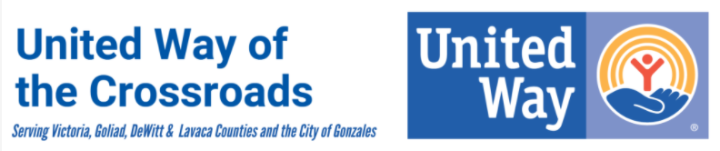

2024-2025 Community Investment Application
Signature Page

By signing below, I certify that I have reviewed and approved the application, financial data workbook, and the attachments for this grant application and that I am prepared to discuss the application during the Community Investment Review process.
I further certify that I understand, if funded, our organization will be required to submit additional attachments, including our Conflict of Interest policy, or Privacy policy, and our Bylaws & Articles of Incorporation, as well as a semi-annual program progress report.

Executive Director Printed Name | Board President Printed Name
Executive Director Signature | Board President Signature
Date | Date

