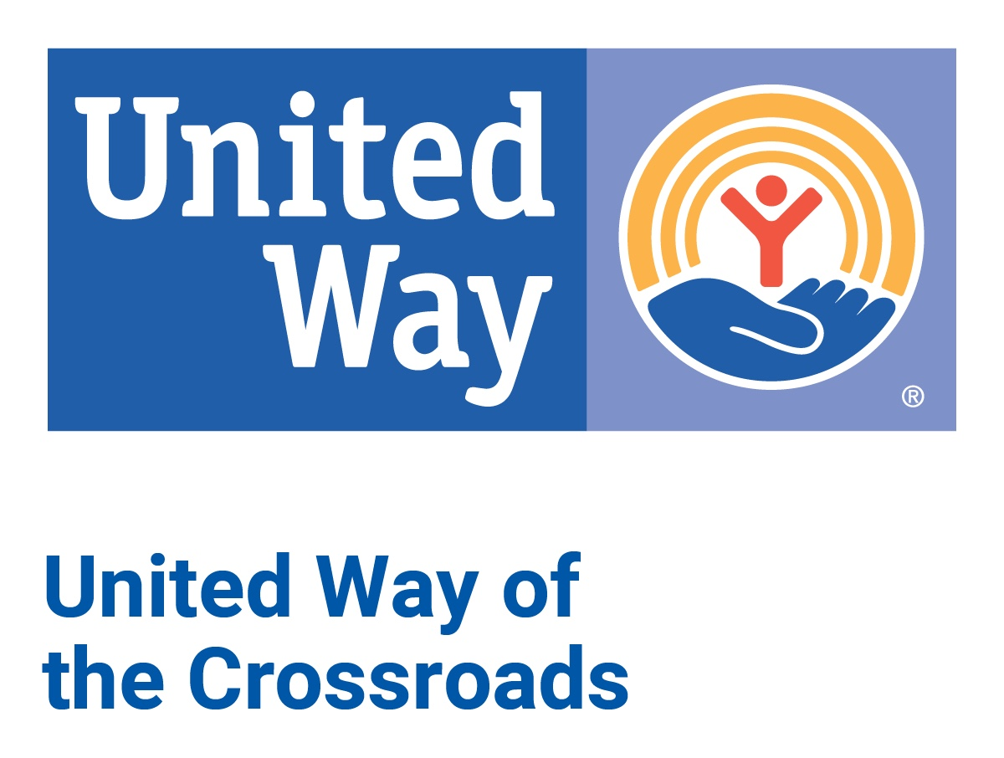

**Community Investment**

**Grant Application**

(2024-2025 funding cycle)

1. **Organization Information**

Organization Name:

Organization mailing address:

Organization telephone number:

Website address:

Federal Employer Identification #:

Total Operating Budget:

Organization’s Fiscal Year:

Number of Employees for Full Organization—

1. Number of full-time employees:
2. Number of part-time employees:
3. Number of volunteers:
4. **Contact Information**

Executive Director/CEO Name:

Executive Director/ CEO Email:

Grant Contact (if different from above):

Grant Contact Email:

1. **Program Information-** specific program for which funds are being requested.

*\*even if funds are used for matching/operational purposes, please name what they are for.*

Program Name:

Total Program Budget:

*\*not your full organizational budget*

Amount of Grant Request:

Number of Employees for this Program ONLY—

1. Number of full-time employees:
2. Number of part-time employees:
3. Number of volunteers:
4. **United Way of the Crossroads Funding Priority Area—**

In regards to your PROGRAM/PROJECT, not organizational:

_____ Education/ Youth Success

_____ Financial Stability/ Economic Mobility

_____ Health

**Program Narrative**

**P1. Program Summary—**

1. Describe how your Program supports your organization’s mission:

*\*Include a brief description of your organization and its mission.*

2. Describe how your Program meets the United Way’s funding priority chosen above.

**P2. Community Needs & Implementation—**

1. Describe who will be served by your program. Include demographics and data about the targeted population group.

2. Discuss collaborations, if any, with other community organizations.

3. How is the program implemented? Include start and end dates for the program cycle.

**P3. Funding Narrative—** this is supplemental to the budget worksheets.

1. How will the requested funds be used?

2. Describe any additional funding needed and anticipated funding sources.

3. If you are not 100% funded, how will your program continue? Will any part of the program be cut? If so, what part will be cut and what will be maintained? How will this impact your projected outcomes and numbers served?

4. How will the program be sustained in the future?

**P4. Evaluation—**

1. What is the expected measurable impact of the project?

2. What outcomes (changes caused by the program) will classify the program a success?

3. What tools will be used to evaluate the program?

4. If this is an ongoing program, please share your data on the impact (outcomes) within the last year. *\*This is not a program success story; this section is for data.*

5. Please share a success story. *specific to the Program/ Project for which funding is requested.

*You may use a separate page or section for this if it is lengthy.

**P5. Diversity, Equity, Inclusion, and Accessibility (DEIA)—**

*\*The United Way network strongly promotes Diversity, Equity, Inclusion, and Accessibility to its members and partner agencies. You can read United Way Worldwide’s shared definition and vision of equity* [*here.*](https://equity.unitedway.org/getting-started/shared-definition-vision-equity)

1. Describe your agency’s experience with, and/or plans for, promoting diversity, equity, and inclusion within your organization. This can include your Board of Directors, agency staff and leadership, and volunteers.

2. Explain how your agency works to ensure diversity among your clients, seeks equitable outcomes for your clients, and is fully inclusive in your service delivery.

3. How do you measure client satisfaction?

4. Describe your organization’s procedures for addressing and resolving client complaints or issues with services. Additionally, please explain how your organization communicates these procedures to clients and ensures that they are followed consistently and fairly.

**P6. Program Service Statistics—**

Complete the P6-Stats tab in the 24-25 Applicant Financial Data Workbook. The Workbook will be submitted according to the Application Instructions.

**Budget**

Program & Organizational

**B1. Program Budget—**

Complete the B1- Program Budget tab in the 24-25 Applicant Financial Data Workbook. Check for special instructions for this tab in the Application Instructions, noting this tab is for the Program only. The Workbook will be submitted according to the Application Instructions.

**B2. Organizational Budget—**

Complete the B2-Org Budget tab in the 24-25 Applicant Financial Data Workbook. Check for special instructions for this tab in the Application Instructions, noting this tab should be reflective of the entire organization. The Workbook will be submitted according to the Application Instructions.

**B3. Historical Financial Information & Overhead—**

Complete the B3- Org Historical & Overhead tab in the 24-25 Applicant Financial Data Workbook. Check for special instructions for this tab in the Application Instructions, noting this tab should be reflective of the entire organization. The Workbook will be submitted according to the Application Instructions.

**Attachments**

Submit all attachments according to Application Instructions

**A1. Signature Page—**

The SCANNED Signature Page authorizing submission of the grant. Must be signed by your organization’s Executive Director/CEO AND the Board President/Chair.

**A2. Audit—**

Most recent organization audit and management letter.

**A3. 990—**

Immediate prior year IRS Form 990; include all sections of the document.

**A4. Board Roster—**

Names and business affiliation of your organization’s governing Board of Directors; identify officers and terms.